Data Technician Workbook
Week 3: Databases & SQL

Name:
Course Date:
Table of contents
Day 1: Task 1 3
Day 1: Task 2 3
Day 3: Task 1 4
Day 4: Task 1: Written 6
Day 4: Task 2: PostgreSQL Practical 9
Course Notes 19
Additional Information 19

Day 1: Task 1

Place/paste your ERD image here:

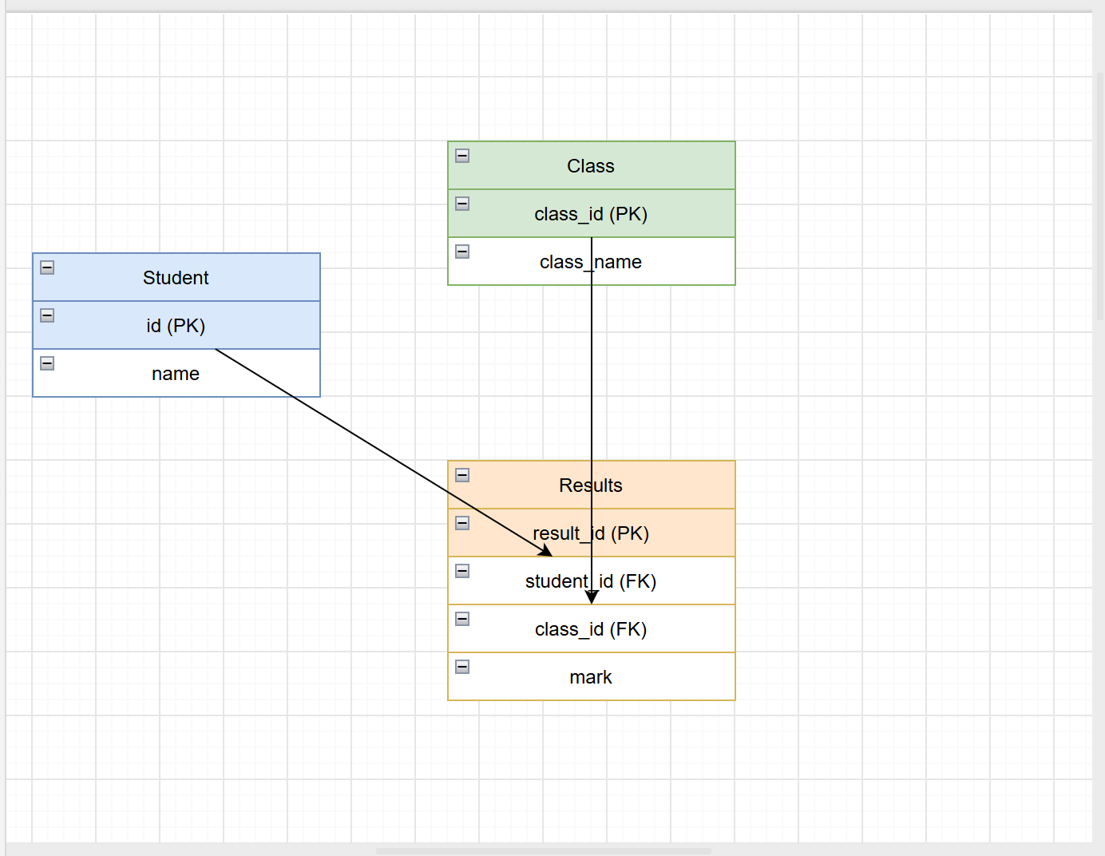

Next,

Please research and complete the questions below relating to key concepts of databases.

What is a primary key? | A primary key is basically the ID tag for each row in a table. It stops the database getting confused between two similar-looking records, like two customers both called J Smith, because every row gets its own unique reference that can't repeat and can't be left empty.  Source: https://dbschema.com/blog/tutorials/sql-what-is-a-primary-key/
How does this differ from a secondary key? | if a primary key is the strict, one-per-person ID, a secondary key is more like a shortcut for finding things. It won't stop duplicates, but it makes searching faster, like looking someone up by surname instead of their exact ID number.  Source: https://www.geeksforgeeks.org/dbms/types-of-keys-in-relational-model-candidate-super-primary-alternate-and-foreign/
How are primary and foreign keys related? | think of a primary key as someone's unique ID card, and a foreign key as a photocopy of that ID kept in a different filing cabinet. The photocopy links the two records together, but it doesn't need to be one of a-kind in its own cabinet, because lots of records can point back to the same person.  Source: https://www.astera.com/type/blog/primary-key-vs-foreign-key
Provide a real-world example of a one-to-one relationship | A person and their passport number is a solid everyday example. Each person has one passport, and that passport belongs to exactly one person, so in a database you'd link the "Person" table and the "Passport" table with a one-to-one relationship, rather than letting either side have several matches.  Or  A country usually has one official capital city, and a capital city is the capital of only one country  Sources: https://www.sqlservercentral.com/articles/database-modeling-relationships  https://creately.com/guides/what-is-a-one-to-one-relationship/
Provide a real-world example of a one-to-many relationship | think of a customer at a shop who placed several orders over the months. That customer only has one customer record, but that one record links out to lots of separate orders. In the database, the Customer ID sits as the primary key in the Customers table, and the same Customer ID shows up again and again in the Orders table as a foreign key, once for each order they've made.  Sources: https://help.claris.com/en/pro-help/content/one-to-many-relationships.html
Provide a real-world example of a many-to-many relationship | think of a college where each student takes several modules, and each module has lots of different students sat in it. Neither the Students table nor the Courses table can hold that link on its own, so you need a third table in between, often called something like Enrolments, which just pairs up student IDs with course IDs, one row per enrolment.  Sources: https://www.dbta.com/Editorial/Think-About-It/The-Supernatural-Many-to-Many-Relationship-169360.aspx  https://creately.com/guides/many-to-many-relationships-in-er-diagrams/

Day 1: Task 2

Please research and complete the questions below relating to key concepts of databases.

What is the difference between a relational and non-relational database? | A relational database is like a well-organised filing cabinet, everything sits in neat, labelled folders that link to each other. A non-relational database is more like a big flexible storage box, useful when your data, such as images or documents, doesn't fit that neat folder structure and needs more room to change shape.  Sources: https://aws.amazon.com/compare/the-difference-between-relational-and-non-relational-databases/  https://www.coursera.org/articles/relational-vs-non-relational-database
What type of data would benefit off the non-relational model?  Why? | this type of data suits a non-relational model because it doesn't naturally sit in tidy rows and columns. Something like a video file or a customer's changing set of preferences needs room to grow and change shape, and a non-relational database lets you do that without redesigning the whole structure every time something new gets added.  A relational table needs every row to follow the same layout, so if one record has ten fields of information and another has three completely different ones, you end up with lots of blank columns or messy workarounds.  Sources: https://www.mongodb.com/resources/compare/relational-vs-non-relational-databases

Day 3: Task 1

Please research the types of 'JOIN ' below, explain what they are and provide an example of the types of data they would be used on.

Self-join | A self-join is handy when a table already contains the answer you need, just hidden across different rows. A good example is an employees table where each row has an employee and their manager ID, since managers are also employees. By joining the table to itself, you can list each employee alongside their manager name in one result, without needing a separate managers table.  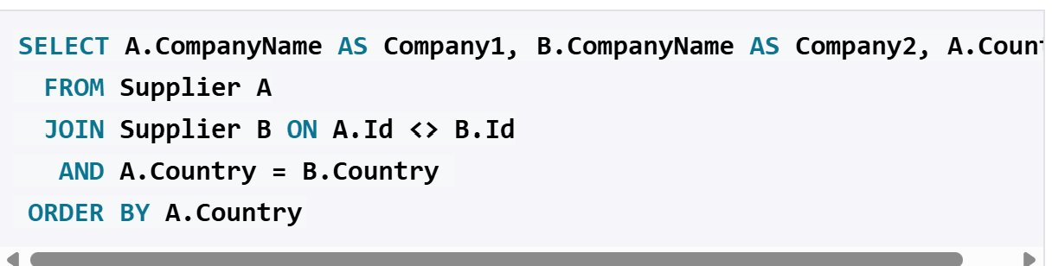  Sources:  https://hightouch.com/sql-dictionary/sql-self-join  https://www.dofactory.com/sql/self-join
Right join | A right join keeps everything from the second table no matter what, and only brings in matching bits from the first. A good example is a departments table and an employees table, where you want to see every department listed, even the ones with no staff assigned yet. The department names would all show up, but any department without employees would just show blank or null values where the employee details would normally be.  Sources: https://www.geeksforgeeks.org/sql/sql-right-join/  https://hightouch.com/sql-dictionary/sql-right-join
Full join | Full join is the show me everything option. A good example is comparing two customer lists from different regional databases, where you want to see every customer from both sides, including the ones that only appear in one list.  Sources: https://www.geeksforgeeks.org/sql/sql-full-join/  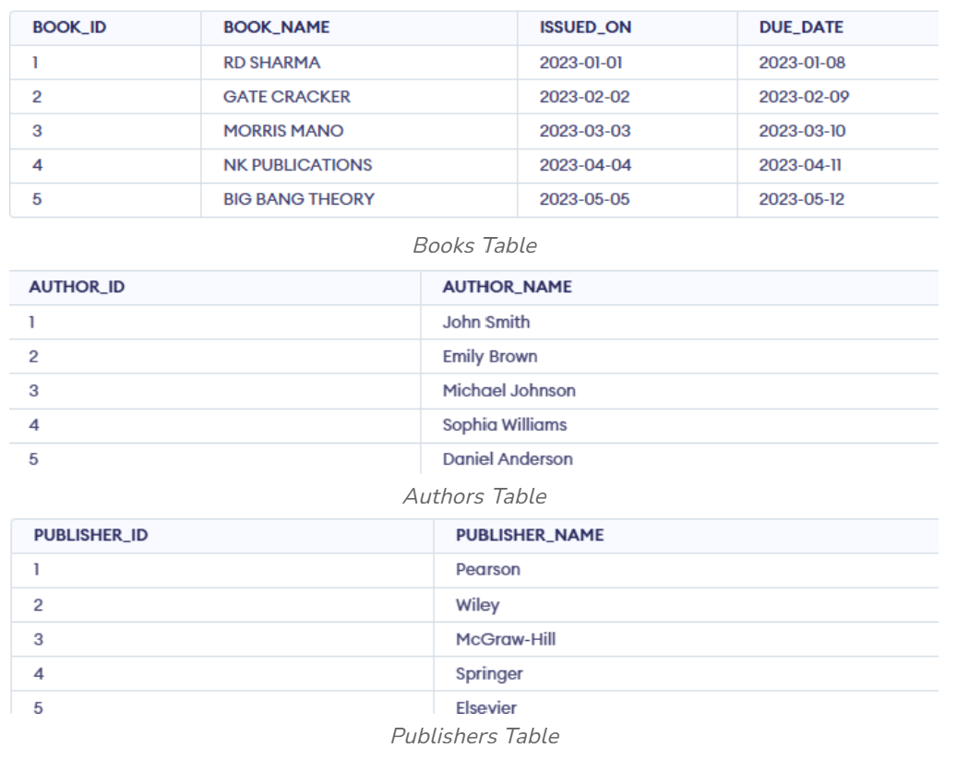
Inner join | Inner Join only keeps rows that match up on both sides. Only customers who've actually placed an order would appear in the results, because anyone without a matching order gets left out completely.  Sources: https://www.geeksforgeeks.org/sql/sql-inner-join/  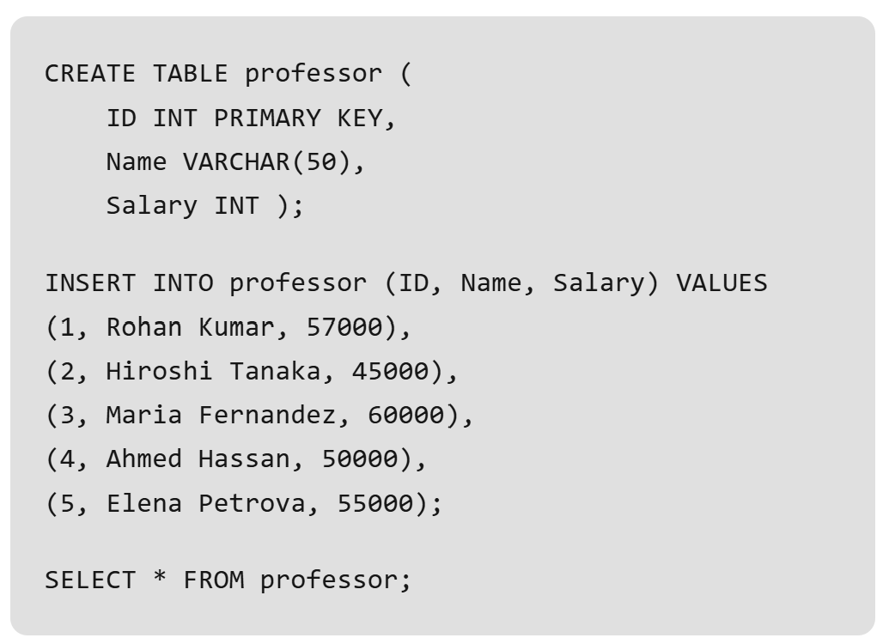
Cross join | is about generating every possible pairing rather than matching related data. If there are 5 shirts and 4 pairs of trousers, a cross join gives you all 20 possible pairings, since it doesn't check whether they relate to each other at all, it just pairs everything with everything.  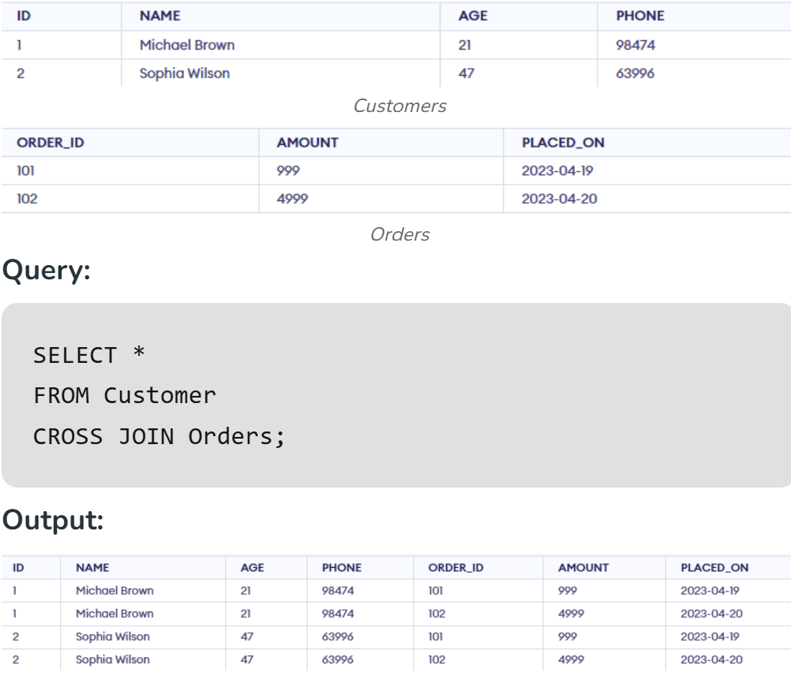  Sources: https://www.geeksforgeeks.org/sql/sql-cross-join/
Left join | it keeps everything from the first table no matter what, and only pulls in matching details from the second table where they exist.  Sources: https://learnsql.com/blog/what-is-left-join-sql/  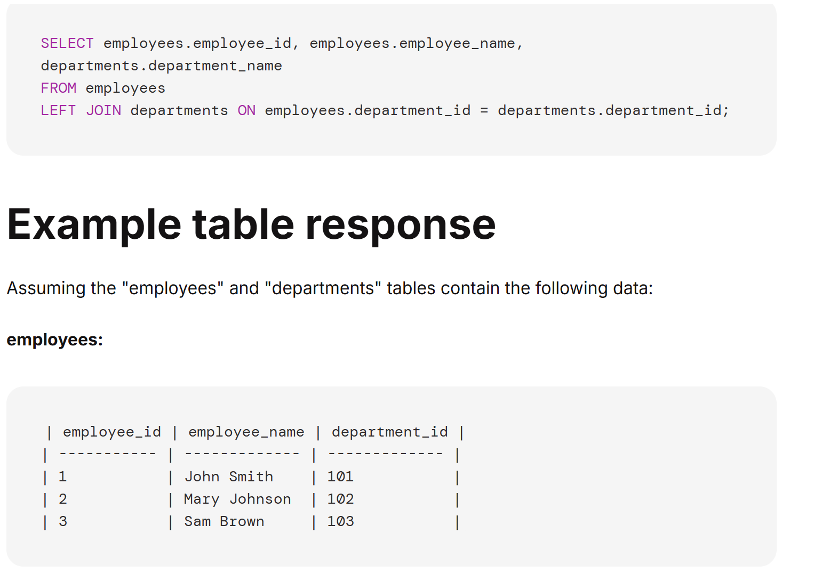

Day 4: Task 1: Written

In your groups, discuss and complete the activity below. You can either nominate one writer or split the elements between you. Everyone, however, must have the completed work below:

Imagine you have been hired by a small retail business that wants to streamline its operations by creating a new database system. This database will be used to manage inventory, sales, and customer information. The business is a small corner shop that sells a range of groceries and domestic products. It might help to picture your local convenience store and think of what they sell. They also have a loyalty program, which you will need to consider when deciding what tables to create.

Write a 500-word essay explaining the steps you would take to set up and create this database. Your essay should cover the following points:

- Understanding the Business Requirements:

- What kind of data will the database need to store? Inventory (SKU - product name, product category, price, stock count, supplier ID); SKU - sales (transaction ID, transaction date, quantity, customer ID); suppliers SKU (supplier ID, supplier name, supplier contact details), customer info SKU (customer ID, name, address, contact number, email, membership status, points total), loyalty (membership no). .

Note: SKUs, in this case, are fields in a table.

- Who will be the users of the database, and what will they need to accomplish?

- Designing the Database Schema:

- How would you structure/design the database tables to efficiently store inventory, sales, and customer information? Can you design it in Word doc.?

- What type of relationship/s between tables are necessary (and can you mention the PK and FK keys) (e.g., how sales relate to inventory and customers)?

- Implementing the Database:

- What SQL commands would you use to create the database and its tables? Top 4 or 5 queries.

- Provide examples of SQL statements for creating tables and defining relationships between them. Top 4 or 5.

- Populating the Database:

- How would you input initial data into the database tables? Can you give examples of SQL INSERT or and VALUES statements.

- Maintaining the Database:

- What measures would you take to ensure the database remains accurate and up to date?

- How would you handle backups and data security?

Your essay should include specific examples of SQL commands and explain why each step is necessary for creating a functional and efficient database for the retail business.

Your essay should include specific examples of SQL commands (a total of 3 or 4) and explain why each step is necessary for creating a functional and efficient database for the retail business. Do your research to find the commands and tell me what each command does – in one line.

Please write your 500-word essay here | 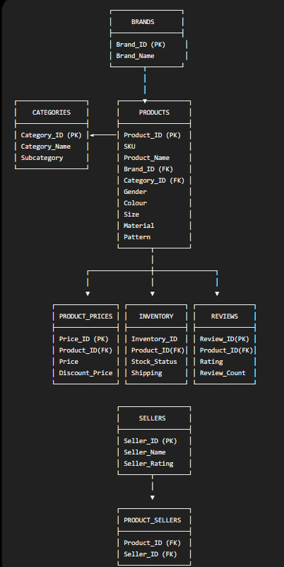  Users: Buying team checks brands, categories, and product listings; store staff check inventory and stock status; e-commerce team manages pricing, discounts, and seller listings; customer service checks reviews and ratings.  Schema: Eight tables — Brands, Categories, Products, Product_Prices, Inventory, Reviews, Sellers, Product_Sellers — each holding a distinct part of the product catalogue rather than one flat table.  Relationships: Brands→Products (one-to-many), Categories→Products (one-to-many), Products→Product_Prices/Inventory/Reviews (one-to-many each), Sellers↔Products (many-to-many via Product_Sellers). Primary keys (Brand_ID, Category_ID, Product_ID, Seller_ID) link out to matching foreign keys.  Implementing: CREATE DATABASE builds the database; CREATE TABLE builds each table; PRIMARY KEY forces uniqueness; FOREIGN KEY links tables together.  Populating: INSERT INTO ... VALUES (...) adds real rows once tables exist.  Maintaining: Update stock and prices regularly, check for duplicate product listings, run scheduled backups, restrict access so only authorised staff can edit pricing and seller data.  Now here's the full detailed version:  Understanding the Business Requirements  Primark needs a database that can handle a large, varied clothing catalogue across multiple brands, categories, and sellers. The data needed includes brand details, product categories with subcategories, individual product listings (SKU, name, gender, colour, size, material, pattern), pricing and discounts, stock levels, customer reviews, and seller information, since some products may be listed through multiple sellers. The people using this database would include the buying team managing brand and category data, store and warehouse staff checking stock through Inventory, the pricing and e-commerce team managing Product_Prices, and customer service staff reviewing ratings and feedback through Reviews.  Designing the Database Schema  The design uses eight linked tables. Brands and Categories sit at the top, each feeding into Products, since every product belongs to one brand and one category. Products then branches out into three tables: Product_Prices (holding price and discount info), Inventory (holding stock status and shipping), and Reviews (holding ratings and review counts). Separately, Sellers links to Products through a joining table, Product_Sellers, since one product can be listed by multiple sellers, and one seller can list multiple products.  Relationships between tables  Brands to Products is one-to-many, linked by Brand_ID as the primary key in Brands and a foreign key in Products. Categories to Products is one-to-many too, linked by Category_ID. Products to Product_Prices, Products to Inventory, and Products to Reviews are all one-to-many, each linked by Product_ID as the primary key in Products and a foreign key in the other table. Sellers to Products is many-to-many, since a single relationship table can't hold two match points directly, so Product_Sellers exists purely to link them, holding Product_ID and Seller_ID as a pair of foreign keys.  Implementing the Database  Five key SQL commands build this structure:  CREATE DATABASE Primark; sets up a new, empty database.  CREATE TABLE Brands (Brand_ID INT PRIMARY KEY, Brand_Name VARCHAR(50)); builds the Brands table with a unique primary key.  CREATE TABLE Categories (Category_ID INT PRIMARY KEY, Category_Name VARCHAR(50), Subcategory VARCHAR(50)); builds the Categories table.  CREATE TABLE Products (Product_ID INT PRIMARY KEY, SKU VARCHAR(20), Product_Name VARCHAR(100), Brand_ID INT, Category_ID INT, Gender VARCHAR(10), Colour VARCHAR(20), Size VARCHAR(10), Material VARCHAR(30), Pattern VARCHAR(30), FOREIGN KEY (Brand_ID) REFERENCES Brands(Brand_ID), FOREIGN KEY (Category_ID) REFERENCES Categories(Category_ID)); builds Products and links it to both Brands and Categories.  CREATE TABLE Product_Sellers (Product_ID INT, Seller_ID INT, FOREIGN KEY (Product_ID) REFERENCES Products(Product_ID), FOREIGN KEY (Seller_ID) REFERENCES Sellers(Seller_ID)); builds the joining table that resolves the many-to-many relationship between Products and Sellers.  Populating the Database  Once the tables exist, INSERT INTO adds real data. For example: INSERT INTO Brands (Brand_ID, Brand_Name) VALUES (1, 'Primark Essentials'); adds one brand record. And INSERT INTO Products (Product_ID, SKU, Product_Name, Brand_ID, Category_ID, Gender, Colour, Size) VALUES (101, 'SKU2201', 'Cotton T-Shirt', 1, 5, 'Womens', 'Navy', 'M'); adds a full product listing linked back to its brand and category.  Maintaining the Database  To keep the catalogue accurate, staff would need to update Inventory stock status after every sale or delivery, keep Product_Prices current during sales and discount periods, and regularly check for duplicate product entries across sellers. For backups and security, scheduled automatic backups should run separately from the live system, and access controls should ensure only authorised pricing and buying staff can edit product and seller data.

Day 4: Task 2: SQL Practical

Complete as many as you can.

Please note: The first couple of queries have no errors; practice keying them manually to understand structure and syntax.

Then the following queries all have minor errors. You will need to use your AI tool to find the error and fix it, then run the query, and explain what you fixed in simple English – only one line explanation is required. (Try to key the code manually where possible.)

Practice using PostgreSQL queries: Use the dataset you have already created in Supabase.
Called: World combined 30. Supabase | The Postgres Development Platform

Once completed, you can save as an SQL file: (Can also save as a CSV file if you want to.)

Go to table editor > Click on the file > click on 3 dots > Export data > Export table as SQL

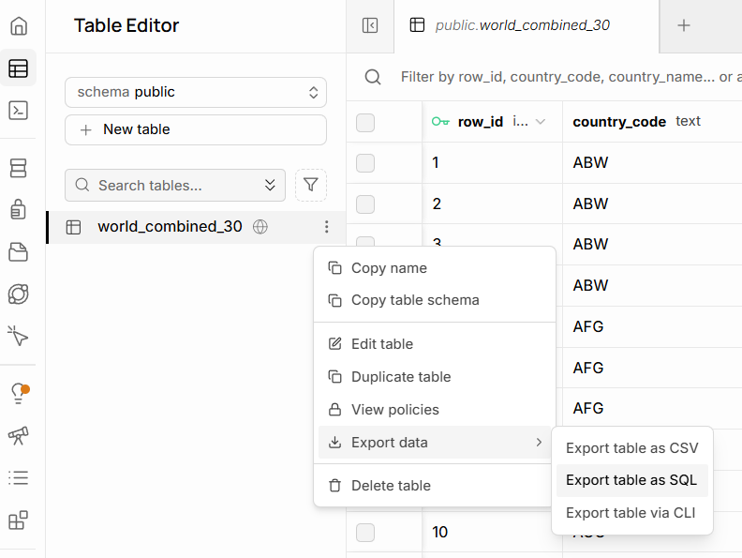

Start running these SQL queries:

Basic selection and filtering
List distinct countries in the table:

SELECT DISTINCT country_name
FROM world_combined_30;

Show all languages for Angola, ordered by percentage (highest first)

SELECT language,
language_percentage
FROM world_combined_30
WHERE country_name = 'Angola'
ORDER BY language_percentage DESC

Find all countries where English appears as a language

SELECT DISTINCT country_name,
country_code
FROM
WHERE language = 'English';

Show all non-official languages for Albania

SELECT language,
language_percentage
FROM world_combined_30
WHERE country_name = 'Albania'
AND is_official = ;

List countries whose population is between 100,000 and 3,000,000

SELECT DISTINCT country_name,
country_population
FROM world_combined_30
WHERE BETWEEN 100000 AND 3000000
ORDER BY country_population;

Fixed: SELECT DISTINCT country_name,
country_population
FROM world_combined_30
WHERE country_population BETWEEN 100000 AND 3000000
ORDER BY country_population;

Aggregation per country
Count how many language rows each country has in DESC order

SELECT country_name,
COUNT(*) AS language_count
FROM world_combined_30
GROUP BY country_name
ORDER BY language_count ;

Show the maximum language percentage per country

SELECT country_name,
MAX(language_percentage) AS max_language_percentage
FROM world_combined_30
GROUP BY country_name
ORDER BY max_language_percentage DESC;

Find countries where at least one language has more than 50% share

SELECT DISTINCT country_name
FROM world_combined_30
WHERE language_percentage > 50;

For each country, show the total percentage of official languages

SELECT country_name,
SUM(language_percentage) AS total_official_percentage
FROM world_combined_30
WHERE is_official =
GROUP BY country_name
ORDER BY total_official_percentage DESC;

List countries that have more than one official language

SELECT country_name,
COUNT(*) AS official_language_count
FROM world_combined_30
WHERE is_official = TRUE
GROUP BY country_name
HAVING COUNT(*) > ?
ORDER BY official_language_count DESC;

Combining filters and aggregates
Show official languages where the percentage is under 10%

SELECT country_name,
language,
language_percentage
FROM world_combined_30
WHERE is_official = TRUE
AND language_percentage ;

Find the country where Arabic is official

SELECT country_name,
country_code,
language_percentage
FROM world_combined_30
WHERE language = ' '
AND is_official = ;

For each country, show the number of non-official languages

SELECT country_name,
COUNT(*) AS non_official_count
FROM world_combined_30
WHERE is_official =
GROUP BY country_name
ORDER BY non_official_count DESC;

List all rows where the city name contains the word ‘la’ (case-sensitive)

SELECT *
FROM world_combined_30
WHERE city_name LIKE '%%';

Show countries whose most spoken language (max %) is not official

SELECT country_name
FROM world_combined_30
WHERE language_percentage = (
SELECT MAX(w2.language_percentage)
FROM world_combined_30 AS w2
WHERE w2.country_name = world_combined_30.country_name
)
AND is_official = ;

Subqueries:

List countries with population above the overall average population

SELECT DISTINCT country_name,
country_population
FROM world_combined_30
WHERE country_population >
(
SELECT AVG()
FROM world_combined_30
);

Show languages that are official somewhere and have ≥ 40% in that country

SELECT DISTINCT language,
country_name,
language_percentage
FROM world_combined_30
WHERE is_official =
AND language_percentage >=

ORDER BY language;
Find countries whose total percentage of all languages is < 100 (data quality check)
Drag selected lines of code and then run, if need be.

SELECT country_name,
SUM(language_percentage) AS total_language_share
FROM world_combined_30
GROUP BY country_name
HAVING SUM(language_percentage) <
ORDER BY total_language_share;

Show rows where the city appears in a country with more than 5 languages
Drag selected lines of code and then run, if need be.

SELECT *
FROM world_combined_30 AS w
WHERE country_name IN (
SELECT country_name
FROM world_combined_30
GROUP BY country_name
HAVING COUNT(*) > ?
);

Course Notes

It is recommended to take notes from the course, use the space below to do so, or use the revision guide shared with the class:

Additional Information

We have included a range of additional links to further resources and information that you may find useful, these can be found within your revision guide.

END OF WORKBOOK

Please check through your work thoroughly before submitting and update the table of contents if required.

Please send your completed work booklet to your trainer.

